CTM-I Use Case

User Maintenance

Version 0.1

Use Case Name | User Maintenance
Actor | Firm User, Market Ops, Ops, App Support
Pre-conditions /Assumptions | User has Browser and is aware of the http path to the application.  User has successfully logged into the CTM-I application.  User has the right role to see the menu options.
Post Conditions | None
Screenshot | 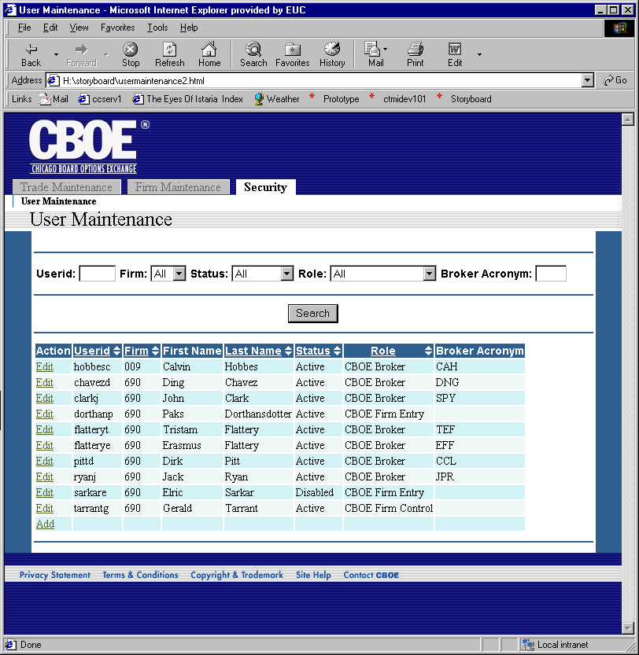
Flow of Events | - User selects “User Maintenance” from the menu.  - User Maintenance screen appears  - User can enter data in the following fields to search by  - Userid  - User can enter a full userid, or just what the userid starts with. For example, entering an “A” would search for all userids that started with “A”.  - Firm  - User can select “All” to search all firms they have access to.  - The list of firms is limited by security  - Users with permissions to select any firm have all firms  - Users with limited firms can select firms they are authorized to see.  - Status  - User can select to search for “All”, “Active” or “Inactive” users.  - Role  - User can select to limit the search by a specific role.  - Broker Acronym (TBD)  - User can enter a Broker Acronym to search by. If a Broker Acronym is entered, all the rest of the criteria are ignored. (TBD)  - User will press the Search button to activate the search.  - Search criteria will be sent to the Security Service for processing. Multiple Search Criteria are treated as Boolean ‘AND’. Default sort from the Security Service should be Firm and Userid.  - The users matching the criteria will be returned by the Security Service.  - The users will be displayed in the User Maintenance screen in a table format  - Standard paging will be allowed on the search results. 30 results will be displayed at a time.  - Paging and sorting will be done on the CTM-I cache and not sent to the Security Service.  - Sorting will be available on the following columns  - Userid  - Firm  - Last Name  - Status  - Role  - Broker Acronym (TBD)  - User will be able to perform an edit action on each user. The edit action will take the user to the User Edit Use Case.  - User will be able to perform an add action to add a new user. The add action will take the user to the User Add Use Case.  - User will be allowed to export the search results to Excel or in a Comma Separated Values file. The exported data will contain all search results, not limited by the trades listed on the screen. (TBD)
Alternative Path | - After performing a search, the user can refresh the data at any time by pressing the search button.  - Search Criteria and current page information will be available to other pages to return to the current search results.  - The Broker Acronym search is not constrained by the authorized firms of the user. If a search is done by Broker Acronym, the search will search only on the Broker Acronym, ignoring any restrictions and other search criteria.

